Bricks and Mortar. . . Linda Lemasters

Disparities Between Urban and Suburban Schools

In America we have accepted that public education is critical to the very foundation of our country. One of the topics that is not always considered when we discuss public education is equity. Are all schools provided with the same resources, quality of teaching, facilities, and parental support? We sometimes do not speak the obvious, but think about the schools you have visited in urban areas and how they differ from schools in the suburbs. The literature exposes the achievement gap in urban and suburban areas, but what about the funding gap? What differences are related to the funding in urban and rural areas?

Some of the funding differences may be due to the sprawl of the suburban areas, with suburban areas having higher transportation and utility costs. A study in Nova Scotia indicated the difference in the city’s annual costs per household between suburban and urban infrastructure and transportation in Halifax was $1,623 USD (Figure 1). What is most interesting about this visual, however, is the difference spent on schools, libraries, and school bussing. . .three items, which may relate directly or indirectly to the achievement gap. Some urban children have no free or public transportation to school and little or no access to libraries and the services they provide.

The consequences of funding disparities in American schools are sobering. “The funding gap shows that many low-income minority students are subjected to inferior facilities, less adequate teachers, and an incomparable curriculum to their counterparts” (Wright, 2012). Russo (2011) made the point more poignant when he wrote about Illinois schools, “In both 2002 and 2011, the 10 poorest schools on average spent 30 percent of what the 10 richest schools spent on average to educate each student. . .”

Let’s look more closely at the impact of the funding gap on school facilities. Local Education Agencies (LEAs) that do not receive adequate funding are putting students at a disadvantage with:
- The most inexperienced and lowest paid teachers,
- Limited access to up-to-date textbooks,
- Limited access to relevant technologies and new computers, (often the older buildings will not accommodate the necessary electrical power for these advances), and
- Poorly furnished science labs.
Often the poorer LEAs cannot focus on:
- The latest in safety measures,
- Cleanliness of hallways, classrooms, and bathrooms,
- Graffiti on walls, lockers, desks, and bathrooms, and
- Maintenance issues, such as ceiling and wall disrepair, broken lights, leaky roofs, and chipped paint.

The Education Trust calculated the funding gap per student by poverty, minority background, and by state, based on data from the U.S. Census Bureau and the U.S. Department of Education, for the 2003-2004 school year. The numbers are staggering for many states. In the State of Pennsylvania, the gap between revenues per student in the highest- and lowest poverty districts is $1,001 and it is $454 per student in the highest-and lowest-minority districts. (Hobson, pp. 17-18)

Wiener and Pristoop (2006) took the per-student disparity and multiplied it by 25 students per classroom to illustrate how funding gaps can add up, classroom by classroom and school by school. Using this method, the projected funding difference in the State of New York between two elementary schools of 400 students—one from the highest-poverty quartile and one from the lowest-poverty quartile—would translate to $927,600 in favor of the richer district. In a similar way, the funding gap between two high schools of 1500 students in the State of Illinois would translate to a disparity of $2,886,000 in funding in favor of the district with less poverty.

Funding inequalities are present in federal, state, and local governments. Equalizing this funding is not likely to equalize the education all students receive; however, it is the first step to enhancing the education of our urban youth. This brings us full circle to what we discussed in the beginning of this blog: Funding does affect the achievement gap. Hobson stated it very well:

The benefits of equal funding, a prerequisite for improving quality education, outweighs [sic] the costs; this is especially true when the positive externalities of a value-added education are analyzed. Some of these positive externalities are: a diverse and skilled workforce, citizens who have a superior understanding of and participation in the democratic process, the loss of incentive to commit crimes as more education translates into a higher income capacity and greater conformity to a set of society values.

It seems only fitting that all students attend school in clean, healthy, safe environments; that they have quality teachers; that we rid our American public education system of the plague of disparities in educational quality and financing.
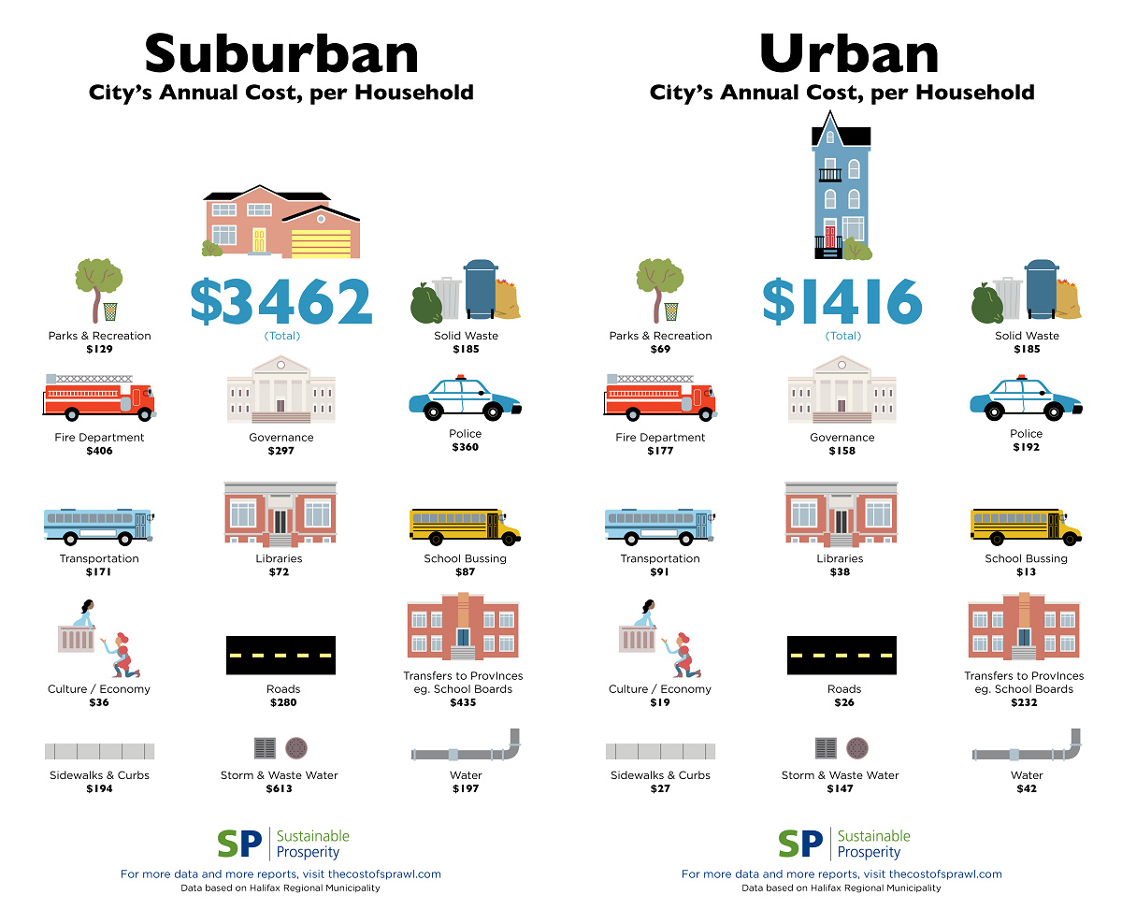
Figure 1: The Real Costs of Suburban Sprawl

References and resources:

Carrasco, A. (2015, March 9). The Real Costs of Suburban Sprawl in One Infographic. Downloaded on May 25, 2015: http://curbed.com/archives/2015/03/09/suburban-vs-urban-infrastructure-costs.php

Hobson, I. The Public Education Funding Dilemma. Downloaded on June 8, 2015: https://www.neumann.edu/academics/divisions/business/journal/Review2013/Hobson.pdf
Russo, A. (2011, November 8). Whatever Happened to School Funding Gaps? This Week in Education. Downloaded on June 6, 2015: http://scholasticadministrator.typepad.com/thisweekineducation/2011/11/the-much-ignored-school-funding-gap.html#.VXWh4mRViko

Wiener, R., & Pristoop. E. (2006). How states shortchange the districts that need the most help. Washington, DC: The Education Trust.

Wright, W. (2013). Proceedings of The National Conference on Undergraduate Research, 2012: The Disparities between Urban and Suburban American Education Systems: A Comparative Analysis Using Social Closure Theory. Ogden, Utah: Weber State University.

Linda Lemasters, Director, Education Facilities Clearinghouse

Linda is an associate professor in the Graduate School of Education and Human Development of The George Washington University, where she teaches graduate level coursework, advises students, and directs student research. Her areas of expertise and research include educational planning, facilities management, and women CEOs. She actively conducts research concerning the effects of the facility on the student and teacher, publishes within her field, and has written or edited numerous books including School Maintenance & Renovation: Administrator Policies, Practices, and Economics and book chapters including a recent chapter, Places Where Children Play, published July, 2014 in Marketing the Green School: Form, Function, and the Future.

